Recommendations for LGMA Harvest Equipment Food Safety Guidelines
Submitted on Behalf of Harvest Forward
Questions or Feedback to joe.stout@cf-san.com

The information is being offered to Western growers as comments towards the LGMA harvest equipment, food safety guidelines update on section 8. Within this document, you will find parts of a total story with recommendations based on five years of focus on harvest, equipment, cleaning and hygienic design. The views are practical and meaningful and will help promote effective and efficient food, safety improvements.

Legend of Comments

Part I – Updated Glossary
Part II – Suggestions for 8-1 update
Part III- Value Added (RTE) vs. Field Pack (RTU)
Part IV - Industry Participation
Part V - Files with background information related to various Harvest subjects

Part I – Glossary
The first Part of recommendation for LGMA Section 8 offers additions and suggestions to help with the understanding of our comments and clarity of LGMA guidance.

Additions to Glossary

LEAFY GREENS DEFINITION  FSC 8915 METRIC A-A-20316B September 6, 2023 | The term “leafy greens” includes iceberg lettuce, romaine lettuce, leaf lettuce, butter lettuce, baby leaf spinach, (i.e., immature, lettuce or leafy greens), escarole, endive, spring mix, spinach, cabbage, kale, arugula, and chard. The term “leafy greens” does not include herbs, such as cilantro or parsley.
LEAFY GREENS READY TO USE DEFINITION  FSC 8915 METRIC A-A-20316B September 6, 2023 | Product is intended for consumption by the public and to be consumed after additional processing such as but not limited to washing or cooking by the end user. (FSC 8915 METRIC A-A-20316B September 6, 2023 COMMERCIAL ITEM DESCRIPTION LEAFY GREENS, PRE-CUT, READY-TO-EAT OR READY-TO-USE The U.S. Department of Agriculture (USDA) has authorized the use of this Commercial Item Description (CID).
LEAFY GREENS READY TO EAT DEFINITION  FSC 8915 METRIC A-A-20316B September 6, 2023 | Product is intended for consumption by the public and to be consumed directly from the container without washing or other preparation. (FSC 8915 METRIC A-A-20316B September 6, 2023 COMMERCIAL ITEM DESCRIPTION LEAFY GREENS, PRE-CUT, READY-TO-EAT OR READY-TO-USE The U.S. Department of Agriculture (USDA) has authorized the use of this Commercial Item Description (CID).
RTE VALUE ADDED PRODUCTS | Value Added Leafy Green are products harvested in the field on equipment requiring direct contact with conveyance with exposure to zones 1 & 2 intersect points. Equipment hygienic design (good and poor) has the potential for niche areas, which require disassembly and periodic equipment cleaning. The priority for Value Added items is to ensure all zone 1 and zone 2 intersects points are clean. Value added products are destined for processing and require additional handling causing more exposure to cross contamination points. Sanitation is critical from the first product / equipment contact forward. Sanitary conditions must be maintained at start up and during operation.
RTU FIELD PACKED ITEMS | Leafy Green products are products harvested and placed in a closed package & placed directly in a lined bulk case. The industry recognizes* the need for clean surfaces with Field Packed items. The difference with Field Pack equipment is the minimal product / equipment contact which offers exposure to intersect points with non-zone 1 areas. The priority for field packed items is to start and maintain clean food contact surfaces throughout the harvest process. This view does not minimize the importance of sanitation with field packed items however, it does recognize that zone one areas are limited to a small area where product is held and wrapped. Sanitation is critical whenever there is exposed product and therefore contact areas must always be clean and sanitary.  - Reference: Periodic Deep Cleaning Study of Harvesting Equipment, 12/1/2021
MASTER SANITATION SCHEDULE | A Master Sanitation Schedule (MSS) is the document which is the list of cleaning tasks with frequencies. It should include Routine and Periodic Cleaning Tasks and seasonal tasks such as Hygienic Design reviews. It is the backbone of sanitation effectiveness and if not applied properly creates risks to food safety.
PERIODIC EQUIPMENT CLEANING | Periodic Equipment cleaning tasks for areas considered hard to reach, hard to see, touch or sample, and therefore need disassembly to enable cleaning. These areas historically are known to have high micro activity based on industry knowledge. The goal should be to convert PECs to Routine cleaning events through hygienic design modifications. This will reduce down-time to allow for harvest equipment up time.
BEST PRACTICES | LGMA to define
CRITERIA FOR AUDIT INCLUSION | LGMA to define

Part II – Suggestions to - Section 8.1 Harvesting Equipment

Harvesting Equipment Hygienic Design

Suggested insertions are noted in Red.

- Design / modify harvest equipment and tools to facilitate cleaning. Food-contact equipment must be constructed and maintained to ensure effective cleaning of the equipment over its lifespan. The equipment should be designed as to prevent bacterial ingress, survival, growth, and reproduction on both food-contact and non- food-contact surfaces. (Moved up from line 1064- 1067, AZ Alignment)

- At least annually, conduct a hygienic design review for harvesting equipment. Document areas of concern and develop and maintain a timeline for the completion of corrective actions. Conduct a corrective action review two times a year. (This adds requirements for an annual review of harvesting equipment hygienic design of to the metrics)

  - For food-contact surfaces, evaluate whether (or not – if not modified, repair or clean more frequently to mitigate risk)
    - They are accessible for cleaning.
    - They are resistant to corrosion, non-toxic, and non-absorbent.
    - They are properly painted or coated.
    - They are ripped, torn, or damaged (e.g., belts and tarps)
    - Belts can be adjusted or removed to allow cleaning of unexposed areas.
    - They are rust-free, and adjacent areas are also rust-free.

  - For machine infrastructure, evaluate whether (or not - if not modify, repair or clean more frequently to mitigate risk)
    - Hydraulic fluid, motors, trash, or oil pans drip, drain or are drawn to food-contact surfaces.
    - Drives, chain guards, control boxes, or bearings are located over open food-contact surfaces.
    - Standing water accumulates, drips, or drains onto food-contact surfaces during operation.
    - Unique features on the harvesting equipment could affect its cleanability or allow for bacterial ingress, survival, growth, and reproduction (e.g., cracks or holes in square tubbing or welds, temporary welds, adjoined flat surfaces “sandwich joints”).

Part III – Suggestions to Section 8.1 Harvesting Equipment Tables differentiating Value Added (considered RTE) from Field Pack (considered RTU)

Insert Table 5 (and Page 5 A below) on Page 18 line # 126 in front of current Table 5. Advance existing Table 5 as Table 6 and so on with subsequent tables.

Table 5 contains expectations for Value Added Products which are considered as RTE, While 5 A is for RTU Products. The differentiation is Value Added is handled extensively by equipment, product is washed. Extra care is supported by product positives at the retail level and by illnesses. Field Pack contacts a small area and is less exposed to contact surfaces, employees, other equipment and the environment. These are considered best practices for Field Packed product.

Information is also provided for measuring and tracking KPIs electronically vs placing in a 3-ring binder. Tracking and trending data is needed for continuous improvement.

Table 5
Value Added Products RTE Expectations and Tracking
Item | KPI measure | Description
Hygienic Design Reviews | % satisfactory and acceptable of list. | Harvest equipment unit hygienic design review and full completed. Recommend at the start of each half year production cycle. (Rating calculation is % Satisfactory and Acceptable of HD List. (HD List is to be maintained with harvest unit or be available electronically)
7-Step effectiveness | % acceptable of list | Complete and document the 7 Step cleaning process using HFC Sani Check list. (% expected / acceptable) for each cleaning event. Maintained in MSS with Harvester or electronically.
Sanitation Chemical controls | % in compliance with targets | Cleaning chemicals / concentrations and usage are documented for each cleaning event. See HFC sanitation chemical Check List. Maintained in MSS with Harvester or electronically.
Pre-op inspections | % compliance for visual inspections & tests | Pre-op inspections, verification data (ATP / APC / visual inspection) of zone 1 surfaces. Target is based on industry / company expectations. Visual inspections are to occur and pass prior to ATP and APC swabbing. Maintained in MSS with Harvester or electronically
Periodic Equipment Cleaning | % completed vs scheduled | Periodic equipment cleaning tasks (PECs) are scheduled and completed. (less than 90% of PECs complete = incomplete) Maintained in MSS with Harvest Unit or available electronically.
Continuous Improvement | Multiple KPIs | KPI measures tracked and trended and used as a roadmap for continuous improvement.
Table 5A
Field Packed RTU Products Best Practices
Item | KPI measure | Description
Hygienic Design Reviews | % satisfactory and acceptable of list. | Harvest equipment unit hygienic design review and full completed. Recommend at the start of each half year production cycle. (Rating calculation is % Satisfactory and Acceptable of HD List. (HD List is to be maintained with harvest unit or be available electronically)
7-Step effectiveness | % acceptable of list | Complete and document the 7 Step cleaning process using HFC Sani Check list. (% expected / acceptable) for each cleaning event. Maintained in MSS with Harvester or electronically.
Sanitation Chemical controls | % in compliance with targets | Cleaning chemicals / concentrations and usage are documented for each cleaning event. See HFC sanitation chemical Check List. Maintained in MSS with Harvester or electronically.
Pre-op inspections | % compliance for visual inspections & tests | Pre-op inspections, verification data (ATP / APC / visual inspection) of zone 1 surfaces. Target is based on industry / company expectations. Visual inspections are to occur and pass prior to ATP and APC swabbing. Maintained in MSS with Harvester or electronically
Periodic Equipment Cleaning | % completed vs scheduled | Periodic equipment cleaning tasks (PECs) are scheduled and completed. (less than 90% of PECs complete = incomplete). Maintained in MSS with Harvest Unit or available electronically.

Part IV - Industry Participation

Harvest Sanitation and Hygienic Design initiatives support

This has been a five-year journey of continuous improvement by the industry, based on science, practical hands-on approaches, taking baby steps leading to continuous improvement. Participation included members from Harvesting companies, Trade groups, Processors, Suppliers, Growers, Customers, Industry Experts, and others. Participation ranged from CEOs to Harvest teams and sanitation crews. Below is a list of persons who have been engaged in meetings and supported the initiative. There are many others - I apologize if I missed other industries and persons as there were many - this was and is an industry initiative with many contributors. Many of these individuals below have been engaged with activities since inception of the Team in August 2019.
Initial Harvest Equipment team attendees on August 16th, 2019
Ashley Avilla | Cosme Pina Taylor Farms | Leticia Reyes Fresh Express
Babiana Urbina Bonduelle | DeAnn Davis Church Brothers | Megan Chadwick Church Bros
Jesus Oseguera Taylor Farms | Marcus Shebl Taylor Farms | German Rios Fresh Express
Xavier Barda Bonduelle | Paul Winter Dole | Trevor Suslow PMA
Joe Stout CFS (facilitator) | Rick Katz CFS | Emily Church Brothers
Harvest Forward Steering Team leadership members-initiated February 2022.
John P Olivo Fresh express | Carter McEntire (McEntire | Bull Hsu Taco Bell
Marcus Shebl Taylor Farms | Ronald Midyett (Dole), | Becky Unwer Walmart
Bob Erickson Foothills Packing | Colby Pereira Braga Fresh | German Rios Fresh Express
Tony Banegas Bonduelle | Glen Almeda Ocean Mist | Felice Arboisiere Dole
Joe Stout CFS (facilitator)
Teams meeting participants on 6/20/24 for review and discussion of directional approach and basis for these comments for proposed changes to LGMA Section 8. There was good discussion and support for the approach as detailed in this document.
Joe Stout CFS (facilitator) | Juan C Vargas Rava Ranch | Carmen Ponce Chipotle
Jacob Odello Foxy Produce | Casey Anderson Robinson fresh | John P Olivo Fresh express
Leticia Reyes Fresh express | German L. Rios Fresh Express | Ly Mai Fresh express
Kristina Nunes Foxy produce | Tony Banegas Bonduelle | Stephen Basore DKM Farms
Alexandra Belias McEntire Produce | Kate Burr Ocean mist | +18052498334
Tom Lovelace McEntire Produce | Jesus Canchola Fresh Express | Art Velazquez Bonduelle
Matt (Unverified) | Fabia Alencar Subway | Felice Arboisiere. Dole Foods
Valentin Sierra Amigo Produce | Megan Chedwick Church Brothers | Handelman,Betsy. Produce Alliance
Miguel Martinez Ag-Pro Sanitation | Megan Arnold. Robinson Fresh | Brad Klemme CFS
Lupe Cameveue Nature Fresh Farm | Becky Unwer. Walmart
Industry participation and support to develop, learn, facilitate, share data. Many of these individuals have been engaged with activities since inception of the Team in August 2019.
Abraham Cardenas Taylor Farms | J Canchola. Fresh Express | Shane Samples Sysco
Adrian Matthews CFA Corp | J. Cambell. Veg Fresh | Sharan Pim 4U
AJU In-out-burger | Jacob Aguirre. Fresh Express | Sam IEH
Alex Recursos solutions | Jaime Taylor Farms | Sanchez Taylor Farms
Alexanda Belias McEntire Produce | Jake Odello. Foxy Produce | Stacy Kinzing Sprouts
Andrew EnglesD. arrigo | Jamie OrtizQ. V Produce | Stephen Basore. DKM Farms
Armado Figueroa Braga Fresh | Jessica Jones. CFA Corp | Suresh Decosta Lipman
Art Velazqez. Bonduelle | Jesus Canchola. Fresh Express | T Granzier Lakeside Produce
Audra Lakeside Farms | J Amaral Foxy Produce | Terry Martin TXM Food Safety
Barb Braden I Love Organic Girl | Jesus Oseguera Taylor Farms | Thea Eubanks I Love Organic Girl
Beatriz Estrada | Jim BrennanT. aylor Farms | Tim York LGMA
Becky Unwer. Walmart | Jim Brennan. Smartwash solutions | Tom Lovelace McEntire Produce
Bibiana Urbina'. Chipotle | Joaquin Valdez. Foxy Produce | Tony Foothill Packing
Bibiana Urbina' Chipotle | John P Olivo Fresh express | Tony Banegas Bonduelle
Bill Hsu Taco Bell | Joe Stout CFS (facilitator) | Trevor Suslow. UC Davis
Bob Ericson Foothill Packing | Joshua Funk. KFC | V Mehta Chipotle
Brett Chaplin Tap Produce | Juan Carlos Vargas. Foothill Pack | V Sierra Amigo Farms
C Nunes Harvest Management | Juan Zendejas Foothill Packing | Valentin Sierra. Amigo Produce
C Shuck Ocean Mist | Justin Kerr Factor Four | Viridiana Melgoza Bonduelle
Caitlin Eden Green | K Malloy Lakeside Produce | Wayne Bailey McEntire Produce
Carlos Costa Farms | K nunes Foxy Produce | A Huguez Mission Ranches
Carmen Ponce Chipotle | Karleigh Bacon. McDonalds | Amy Parks Dole
Carter McEntire McEntire Produce | Kartika Charan Sysco | Brett Champion Taproduce
Casey Anderson Robinson Fresh | Kate Burr. Ocean Mist | David SFCOS
Chad Amaral Darrigo | Kate Marcom | Emanuel Suncoast Farms
Chris Polito Inspire Brands | Kristina Nunes. Foxy produce | E. Morales Jvsmithcompanies'
Colby Pereira Braga Fresh | krodriguez@sfcos.com | Frank Ramsey Highlander
Daniele Garcia Dole | Larry Kohl FMI | Mark Shakespere Walmart
Dave Zada FRESH | Leticia Empire | Robert Perez. Taylor Fsrmsd
David Isaac Garland Chemical | Leticia Reyes Fresh Express | Vicki Scott Arizona LGMA
David Offerdah lSpudnik | Lidia Duda Farms | Karen Rodriguez. Fresh Harvest
Deidra Liddel Hbit Burger | Lupe Cameveue Nature Fresh Farm | Jose Garcia Hitchcock Farms
Dennis Escober QV Produce | Ly Mai Fresh express | Jorge Verdugo Lamco Harvest
Drew McDonald Taylor Farms | M Gordon Costco | Nancy Hericra Hacienda Farms
E Moralesjvsmit hcompanies | M. Machovina Cabbage inc | Steve Basore TKM Bengsrd Farms
Elizabeth Paramo Auto Harvesting | M. Memes True Organic | Jake Drahuschak Agro Mgr
Emanuel Sun Coast Farms | Marcus Shebl. Taylor Farms | Delores Aceves Factor Four
Erendria RC Farms llc | Marj Davis Intralox | Milt Voss Zada FRESH
Erik The Growers Company | Mark Anquiano. The Growers Co | Ed Morales Jvsmithcompanies
F Valdez Sabor Farms | Martin Ayala Vis Veg | Angie Ramirez Triangle Farms
Fabia Alencar Subway | Megan Arnold Robinson Fresh | Rick Katz CFS
Felice Arboisiere Dole | Miguel Martinez Agro Sanitation | Betsy Handelman, Produce All
Fernando Perez The Growers Co | Mike Sexton McEntire Produce
Francisco Noia Wendys | Mike Taylor Former FDA
Frank Yiannis Former FDA | Octavio
G Cruz Monterrey Mushrooms | Paula Fisher Ag
Garrett Turner Foothill Packing | Rafael Valesquez Darrigo
German Rios Fresh Express | Rick Demesa Panda
Giavani Valdez Amigo Farms | Rick Maytorena. Direct Roots
Gillian Kelleher LGSC | Robert Lopez. Taylor Farms
Glen Almeda Ocean Mist | Robin Forgery Costco
Greg Kolmar LGMA | Ronald Midyett. Dole
Hector Pedraza Robinson Fresh | Rudi Groppe. HMI
Isaac Torres Fresh Express | S Basore TKM Farms
Signed as Honorary Supporters for Harvest Forward initiatives in 2024 to encourage supplier participation.
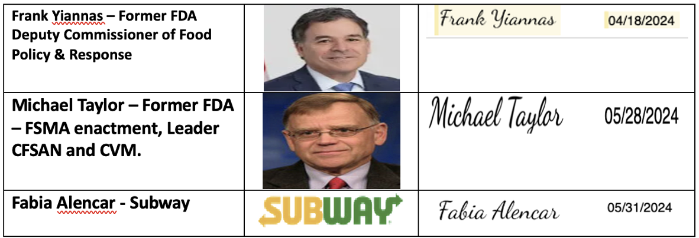
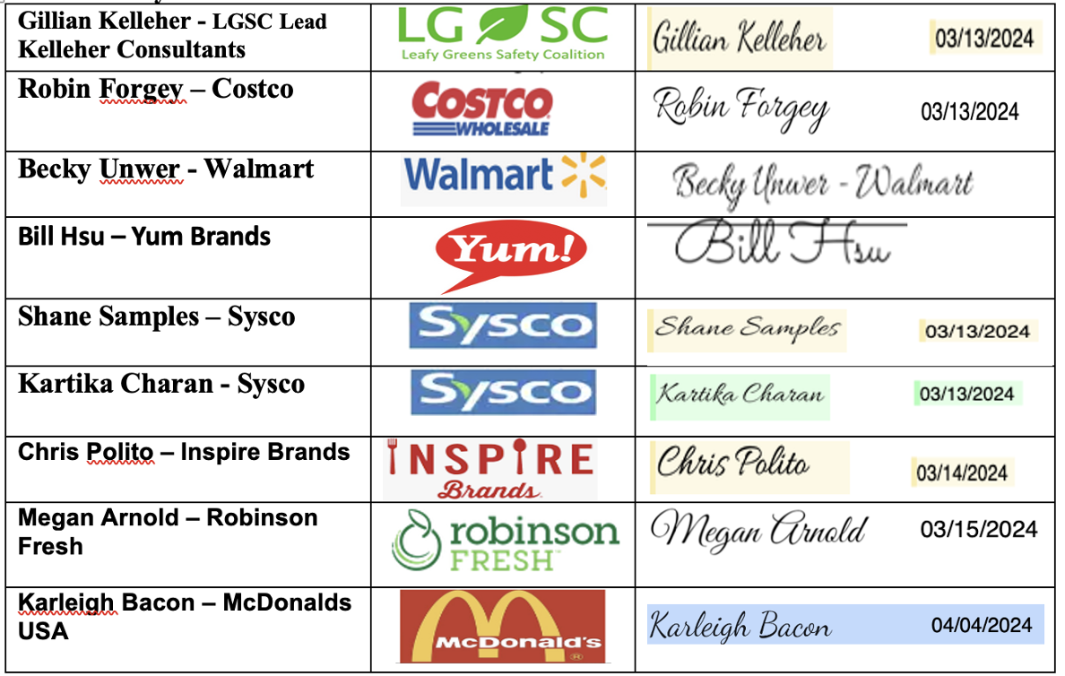
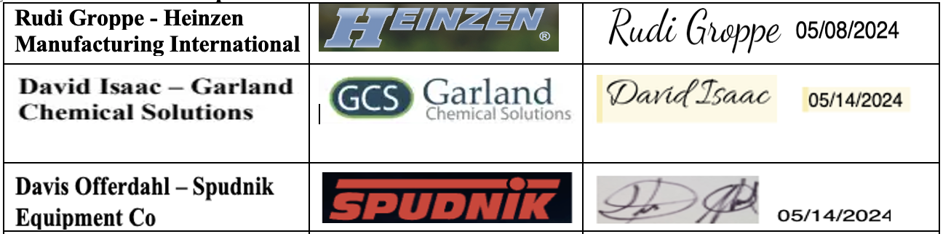
Part V
Files with background information related to various Harvest subjects.
Submitted Files
- Harvest Forward Expectations & KPIs Excel file – lists the harvest Forward Expectations developed by Harvest Forward team use in field harvest programs and KPIs – 7 separate work sheets
  - #1 Sample KPI for collection and reporting of continuous improvement data each month summarized quarterly.
  - #2 Harvest Forward Expectations (also appear in the LGMA comment section)
  - #3 Hygienic Design Checklist developed specifically for use with harvest equipment. Harvest Forward held three in person meeting (70 persons per meeting) they completed design reviews on multiple harvest units.
  - #4 7 Step sanitation process sample inspection check list.
  - #5 Sample recording check list for recording chemical concentrations for tracking with KOIs.
  - #6 Periodic Equipment Cleaning sample schedule and checklist for quarterly monitoring.
- Periodic Deep Cleaning Study of Harvesting Equipment (White Paper) PDF file (2021)
  - Coordinated by Harvester Sanitation & Design Working Group, later called Harvest Forward Coalition
  - Original date of issue December 1, 2021 (updated May 20, 2024)
  - Update From Harvest Forward Coalition includes.
    - Cleaning and Hygienic Design Expectations with KPIs (page2) for tracking improvement
    - Hygienic Design review checklist (page16) specifically for Harvest Equipment
- Harvest Forward Charter – includes mission & scope, HFC owners & Board members, lists the 7-step cleaning process.
- USDA Authorized commercial item description for Leafy Greens, pre-cut, Ready-to-Eat or Ready to Use Metris A-A20316B September 6, 2023.

